**NOISE POLLUTION MONITORING**

**PHASE - 4**

**About Thing Speak:**

ThingSpeak is an IoT analytics platform service that allows you to aggregate, visualize, and analyse live data streams in the cloud. The platform's real-time data management tools facilitate swift decision-making based on live information streams. Its popularity in the IoT landscape stems from the simplicity it offers in channel creation and data manipulation. Whether tracking environmental variables, controlling smart devices, or conducting research, ThingSpeak provides a robust framework. The collaborative nature of ThingSpeak encourages a community-driven approach, fostering the sharing of ideas and code snippets. Overall, ThingSpeak stands as a dynamic hub for IoT enthusiasts, amplifying the potential for innovation in the interconnected world of devices and data.

**Code to display Real time Transit Information on Thinkspeak:**

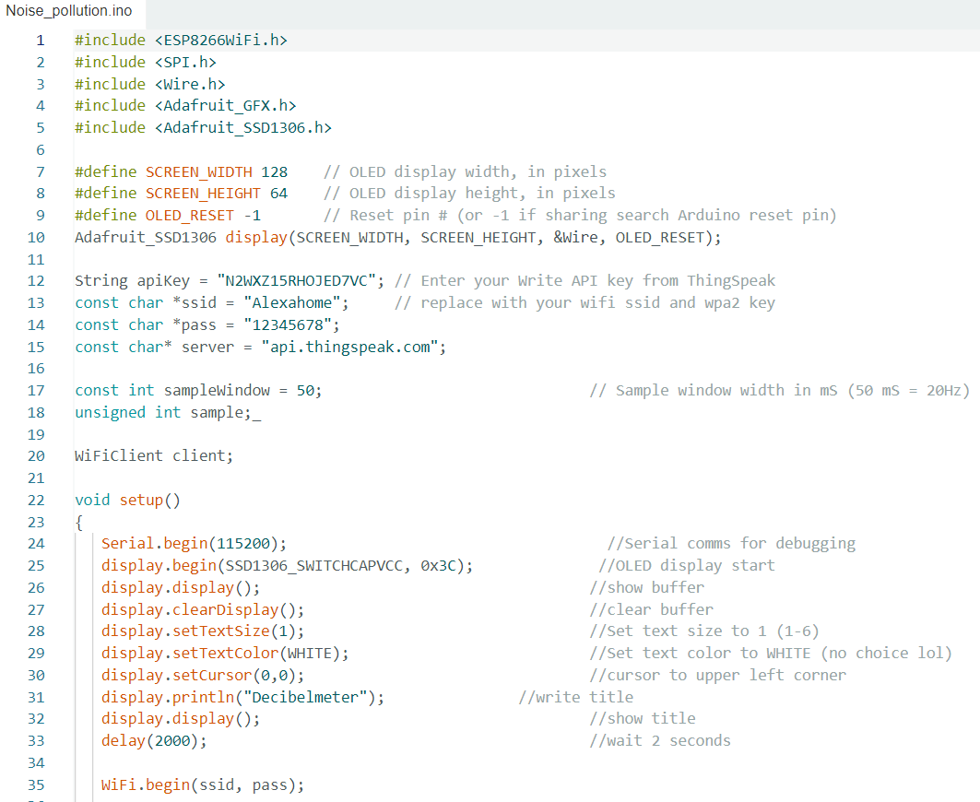

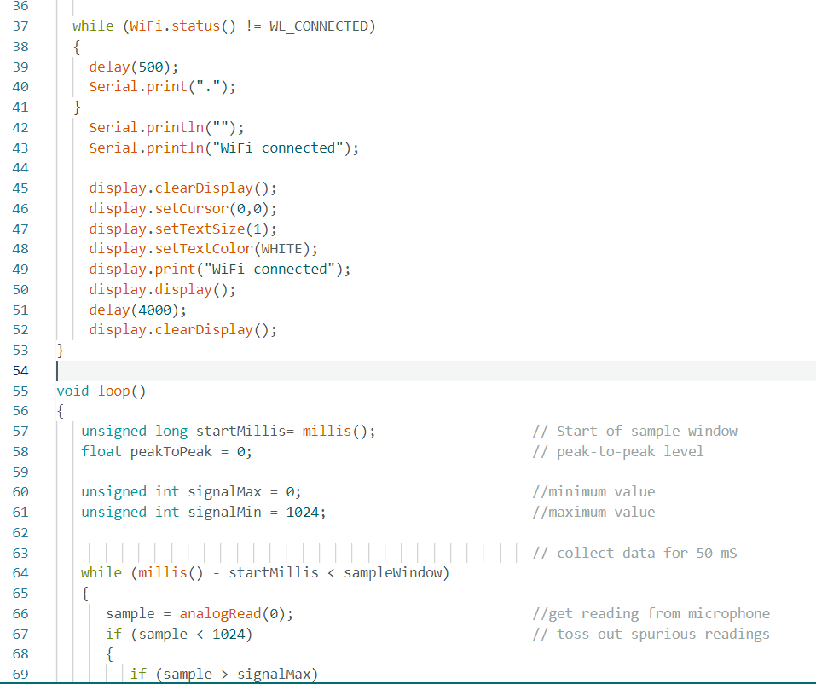

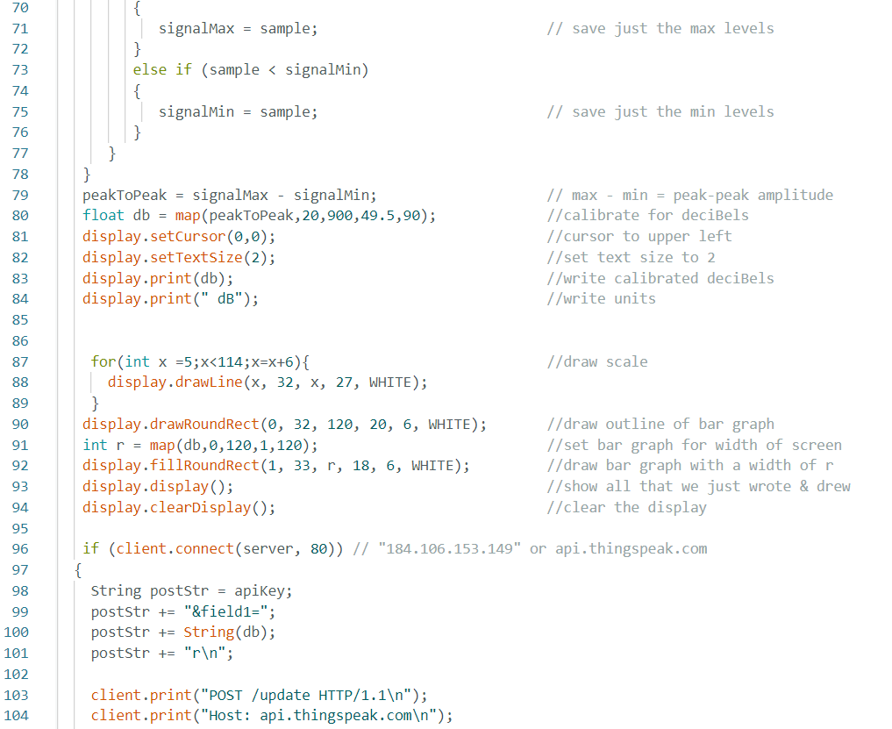

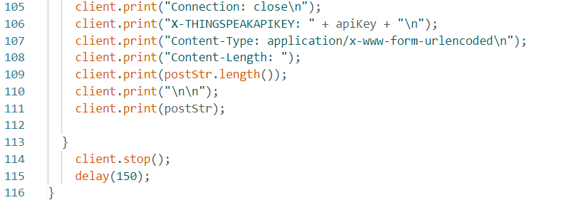

**OUTPUT:**

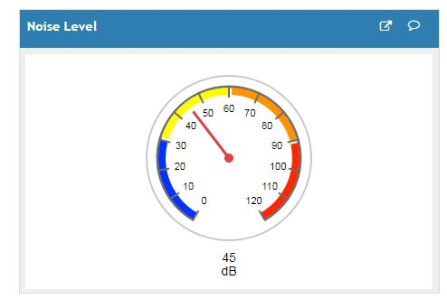

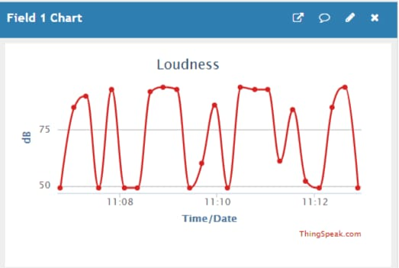

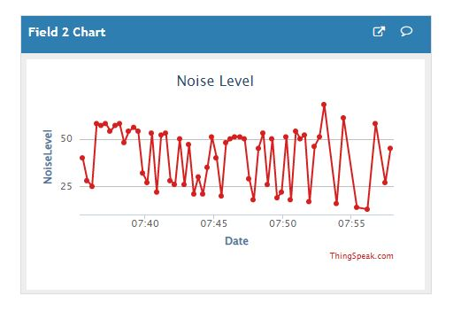

**MOBILE APPLICATION:**

Additionally, MIT App Inventor provides a simple and intuitive interface for testing and debugging apps in real-time. It emphasizes accessibility by enabling users to create functional apps with minimal effort. The platform supports a variety of features, including sensors, media playback, and connectivity options, allowing users to explore diverse app functionalities. MIT App Inventor serves as a valuable resource for individuals looking to kickstart their journey into mobile app development, fostering creativity and hands-on learning.

For collecting and storing real-time transit data, ThingSpeak channels were employed, capturing information like route details, location, and passenger count for each data point. In the MIT App Inventor, a visualinterface facilitated app development, utilizing components like labels, text boxes, and web elements to shape the user interface. To retrieve data, the app was configured to interact with ThingSpeak channels through the Web component, making API calls for the latest entries. The app dynamically displayed the retrieved data, presenting route information, location, and passenger count in real-time on its interface.

**MIT APP INVENTOR:**

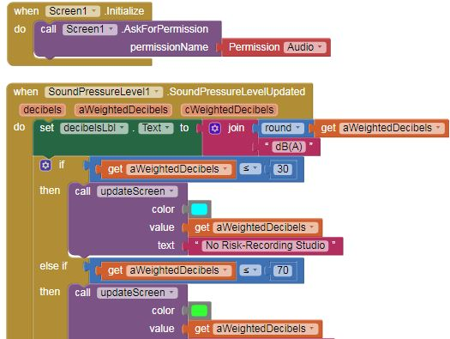

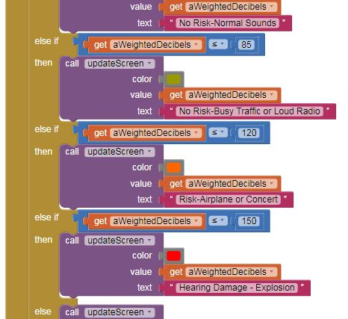

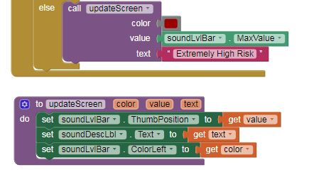

**OUTPUT :**

When noise level <= 120 dBWhen noise level <= 85dB

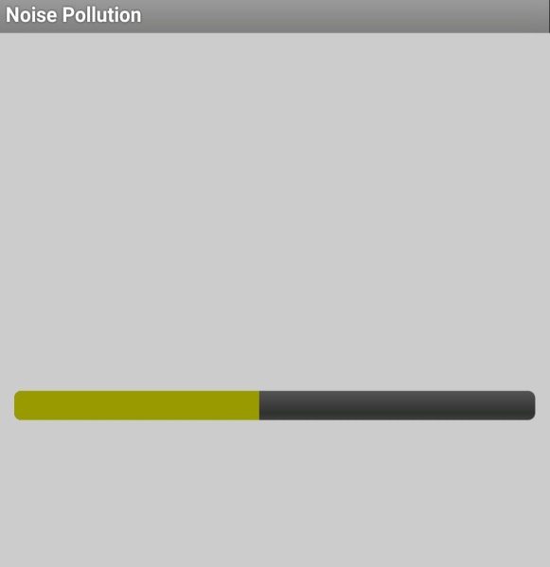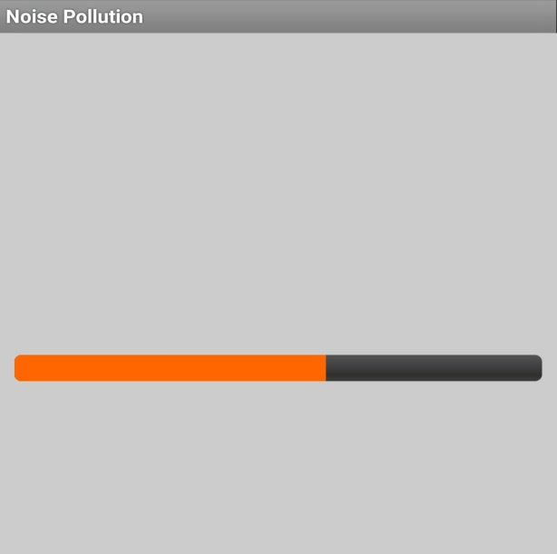

When noise level <= 70dB



**TEAM MEMBERS:**

1. Jayanth N - (2021504523)

2. Lavanya V - (2021504525)

3. Mathana K - (2021504528)

4. Sudhanthira P - (2021504548)

5. Vidhya SS - (2021504557)